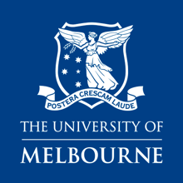
The Melbourne Social Equity Institute in partnership with the Melbourne Indigenous Knowledge Institute

Indigenous Community Fellowships 2021

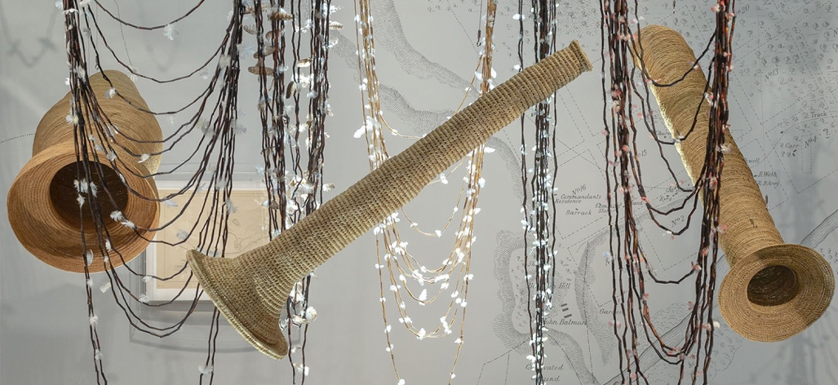
Mutti Mutti/Wemba Wemba/Yorta Yorta/ Boon Wurrung artist Maree Clarke’s Ancestral Memory. Photograph by Christian Capurro.

About the Community Fellowships
- Aim to meet the research needs of community organisations to conduct small research projects
- Projects could involve conducting a scoping report, literature review, data analysis, a small research project leading to positive outcomes, improved capacity to undertake future research and more

Benefits
- Up to $5000 to the community organisation to compensate for the time the Fellow spends working at the University of Melbourne
- Outcomes of the research project, and research capacity building for the Fellow and community organisation
- Academic mentoring and research skills training for the Fellow
- Library access, hot-desking space (subject to COVID-19 restrictions), internet facilities and a University email address

Eligibility
Up to two Indigenous Community Fellows will be appointed who:
- Identify as Aboriginal and/or Torres Strait Islander
- Are working at an Indigenous community organisation or focusing on an Indigenous topic in their Fellowship proposal
- Meet the general criteria for the Community Fellows application
No prior research experience is required. The program is not suitable for applicants with a PhD or significant research experience.

How to apply
Find out more at the website: https://socialequity.unimelb.edu.au/community-fellows-program
Applications must be submitted by 12pm on Friday 23rd October 2020

Contacts

Aurora Milroy
Manager, Melbourne Indigenous Knowledge Institute
aurora.milroy@unimelb.edu.au
Charlene Edwards
Executive Officer, Melbourne Social Equity Institute
charlene.edwards@unimelb.edu.au

