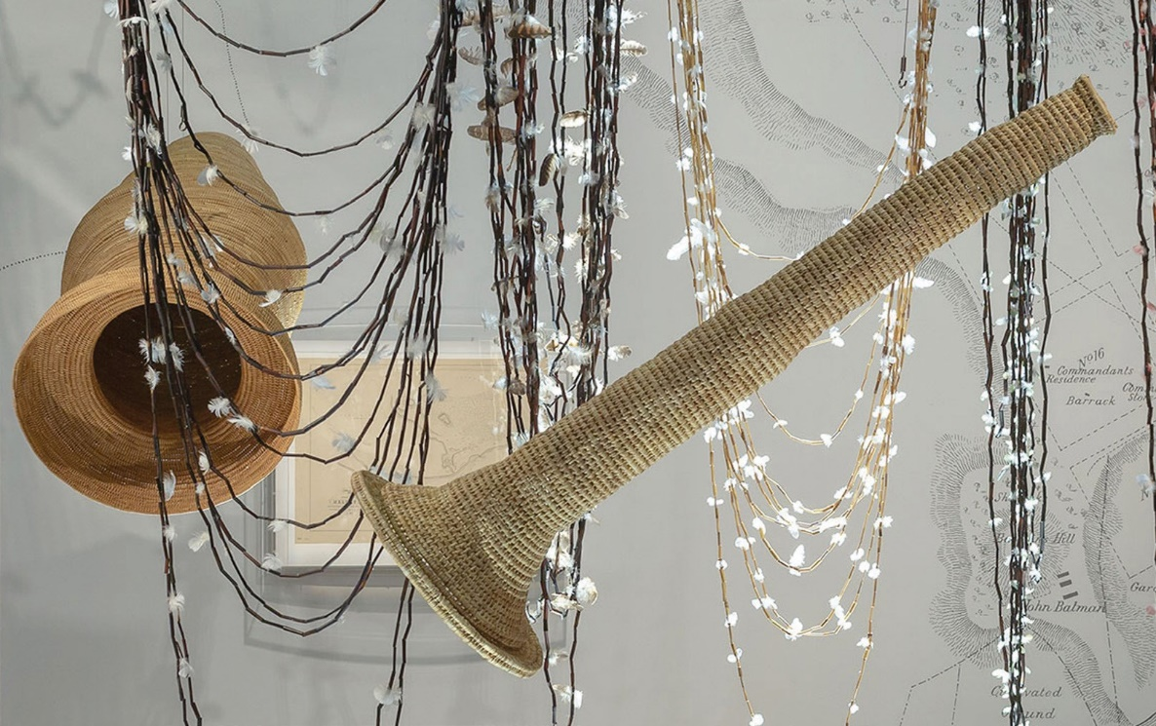

—
Indigenous Knowledge Institute
—
Indigenous Knowledge Institute

IKI Indigenous PhD Bursary Application Form 2023

The Indigenous Knowledge Institute (IKI) invites applications for 2023 PhD Bursaries. Two bursaries are available each year.
All applications should be submitted to IKI at Indigenous-knowledge@unimelb.edu.au. Please get in touch if you have any questions about the application.
Successful applicants will be asked to participate in a news article promoting the PhD bursaries.
Value | $5,000 per annum* (up to a total of $15,000)
Number of bursaries available in 2023 | Two
Application timeline | Applications open 7 April 2023  Applications close 29 May 2023  Funding outcomes week of 12 June 2023  First payment made early July  Subsequent payments made in January each year
* Successful applicants who study part-time may opt to be paid at $2,500 per annum over six years (up to a total of $15,000).

Eligibility
- Only domestic applicants may apply.
- Applicants must identify as Aboriginal and/or Torres Strait Islander.
- Applicants must have received a letter of offer to undertake a Doctor of Philosophy at the University of Melbourne in 2023. The research project must be related to Indigenous knowledge systems.
  - If you are a later year PhD student, please get in touch with us before applying.
- Applicants must not already have received a PhD bursary from the Indigenous Knowledge Institute.
PART A. Applicant Details
A1. Given name:

A2. Family name:

A3. Email address:

A4. Phone number:

A5. Are you an Australian citizen or permanent resident?
☐ Yes, Australian citizen or permanent resident
☐ No
A6. Do you identify as Aboriginal and/or Torres Strait Islander?
☐ Yes, Aboriginal and/or Torres Strait Islander
☐ No
PART B. Project Details
B1. Name of your PhD supervisor(s):

B2. Your PhD Faculty:

B3. Please describe your relevant experience or qualifications. (300 words maximum)

B4. Please describe your project and how it incorporates Indigenous knowledge systems. (300 words maximum)

B5. The Indigenous Knowledge Institute is committed to collaboration with Indigenous knowledge holders that are guided by core principles to ensure ethical, respectful, and responsible relationships are developed and honoured.
Please briefly describe how your research project addresses the principles in the IKI Charter for Research with Indigenous Knowledge Holders. (300 words maximum)

PART C. Attachments
Please include with your application form:
- A copy of your PhD offer letter.
- A copy of your research proposal.
Please send completed applications to the IKI email address:
Indigenous-knowledge@unimelb.edu.au
Applications close on 29 May 2023.

